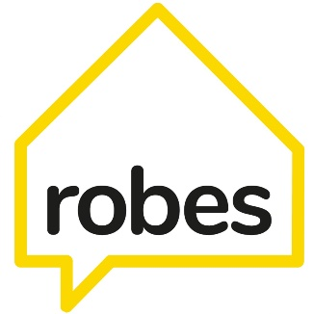
Robes Project
Sponsorship & Gift Aid Declaration Form
www.robes.org.uk Charity Registration Number: 1174060
www.justgiving.com/campaign/southwarkcathedralsleepout2023
Southwark Cathedral
Montague Close
London | SE1 9DA

cathedral@robes.org.uk
Tel: 020 7407 5623

Thank you so much for participating in SleepOut 2023, presented by Southwark Cathedral on behalf of Robes. We’re really pleased you chose to take part.
Please note that you can donate through the Just Giving web address above. However, if you would prefer to donate via cheque (made payable to the Robes Project), then you can return the completed form along with your cheque to the address above.
Please mark the envelope “SleepOut” and return as soon as possible after the event (no later than 31st January 2024).

Gift Aid – In order for Robes to reclaim an additional 25p for every £1 raised, at no extra cost to yourself or your sponsors, please ask your sponsors to enter their details in each column below and put a tick in the right hand column.
* Sponsors, please note that if you are not a UK taxpayer, or if you pay less income tax and / or Capital Gains Tax in the current tax year than the amount claimed on all your donations, then HMRC may require you to pay the difference

IMPORTANT - please remember to fill in all the boxes

Participants Name

Title | First Name / Initial | Surname | House Name / Number | Postcode | Donation Date | Amount Donating | Gift Aid
(Up to 4 letters) |  | (Up to 35 characters) | (Up to 40 characters) | (UPPER CASE with space) | (DD/MM/YYYY) |  | (Tick if yes)

Title | First Name / Initial | Surname | House Name / Number | Postcode | Donation Date | Amount Donating | Gift Aid
(Up to 4 letters) |  | (Up to 35 characters) | (Up to 40 characters) | (UPPER CASE with space) | (DD/MM/YYYY) |  | (Tick if yes)

